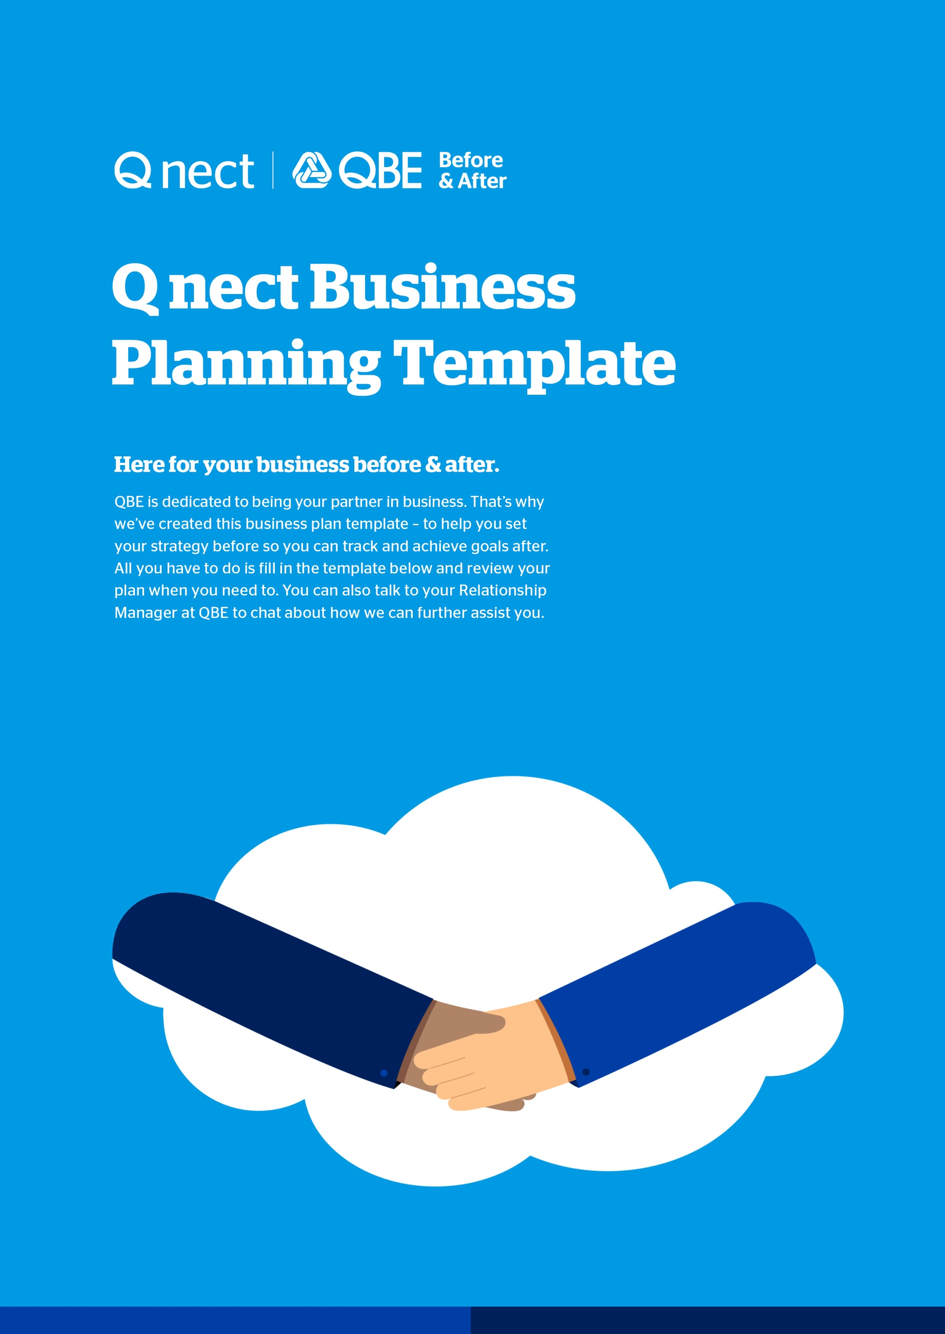

Business details
These are the practical details of your business. Feel free to add rows for extra information as needed.

Your name | Enter your name and title as applicable
Business name | Enter your business name
ABN | Enter your Australian Business Number (ABN)
Address | Enter your business address
Phone | Enter your business phone number
Email | Enter your business email address
Date prepared | Enter the date your prepared this document

Business summary
This is a summary of your business purpose. Please be as descriptive as possible.

Mission statement | A statement about your current business purpose. This is a more practical explanation on what your organisation does and how it operates. Questions to answer include: what do we do? Who do we serve? How do we serve them?
Vision statement | A statement about the desired future position of your business. Questions include: what are the hopes and dreams of the business? What problem are we solving for our customers? Who or what are we inspiring?
Core values | This is a set of guiding principles for your business. It helps clarify who you are to people that join your company or work with you. Try to keep to five key descriptive words or phrases.

Goals and objectives
Outline your short and long term goals. You can add rows as needed. Please remember to keep your goals SMART (Specific, Measurable, Attainable, Realistic and Timely).

Short term goals – Goals for year one of the business
Goal | Action | Deadline | Responsibility
Enter your goal. | Enter the action that you will take to achieve the goal. | Give yourself a deadline. | Allocate a person responsible for achieving the goal.

Long term goals – Future goals of the business.
Goal | Action | Deadline | Responsibility
Enter your goal. | Enter the action that you will take to achieve the goal. | Give yourself a deadline. | Allocate a person responsible for achieving the goal.

Market research
This is the homework section of the plan. It’s an opportunity to reflect on the market around you so that you can best position your business for success.

Target market
Type | Location | Size | Influences | Opportunities
This can include people and their demographics, industries or specific businesses. | Where they are located. | How big is the industry or demographic? Can include the number of consumers and potential revenue. | What are the environmental, social, political or economic factors that may influence their purchasing habits? | What are the growth opportunities for this market?

Competitors
Competitor name | Target market | Strengths | Weaknesses
Name and details of your competitor. | Who their target market is. | A list of their strengths. What do they do well? What can you learn from them? | A list of their weaknesses. Where are the opportunities for you to grow?

Suppliers
Supplier name | Products | Relationship Manager
The name of the supplier, such as QBE Insurance. | What products they offer you and your target market/s. | Contact details of supplier.

SWOT analysis
You can analyse your business Strengths, Weaknesses, Opportunities and Threats (SWOT) with this tool.

Strengths | Weaknesses
- What do you do well?  - What are the unique resources or knowledge that you can draw on?  - What do other people see as your strengths?  - What can you offer that nobody else can? | - What could you improve?  - Where do you have fewer resources?  - What are others likely to see as a weakness?
Opportunities | Threats
- What opportunities are you open to?  - Where can you grow your business?  - What trends could you take advantage of?  - How can you turn your strengths into opportunities? | - What internal threats could harm your business? (e.g. operations, finance)  - What external threats could harm your business? (e.g. competitors, market forces)  - How do you weaknesses become threats?

Marketing
You can outline how you plan to promote and market your business and how much you want to invest in marketing.

Marketing
Tactic | Audience | Investment
The marketing tactic you will undertake e.g. flyers to local businesses, word of mouth (WOM), speaking at conference and more. | The audience you will target with this tactic. | The monetary investment you will make into this tactic.
 | Total Investment | $

Online Channels
Total Budget: Total $ investment you will make into your online presence.
 | URL | Audience
Website | Enter your website URL | Enter your target audience for this platform
Facebook | Enter your Facebook URL (if applicable)
Instagram | Enter your Instagram handle (if applicable)
Twitter | Enter your Twitter URL (if applicable)
LinkedIn | Enter your LinkedIn URL (if applicable)
YouTube | Enter your YouTube URL (if applicable)

Financials
Here you can enter the financial plan for your business, including a forecast for your first few years in business.

Financials
Start-up cost | Enter the estimated amount it will or has cost to start up your business.
Funding | Detail your sources of funding.
Break even date | Set an estimated date for when you will break even.

Profit and loss forecast
 | First year | Second year | Third year
Estimated sales | $ | $ | $
Estimated costs | $ | $ | $
Estimated profit/loss | $ | $ | $

Resources
This is a list of resources that you can draw upon. We suggest updating this section regularly as you find more information or contacts that could be useful to your business.

Resource | Type | URL/Contact
Name of resource | Type of resource (e.g. e-learning, personal contact) | Link or contact details of the resource.

